Brochure by Daisy Ayon
Art 305, Spring 2015
Cal State University, Long Beach
Megan Geckler

Site-specific

Installation Artist

Artist Background

- Megan Geckler was born in Bucks County, Pennsylvania on
October 8, 1975.

- She was in pre-med school when she decided that she was going to quit and get into art school.

- Her main material in her pieces is flagging tape in all of the colors available.

- Megan’s personal interest are color theory, design, contemporary art, architecture, plastics, 3D modeling, and installation art.

- Geckler obtained her Bacherlors in Fine Arts (BFA) from Tyler School of Art in 1998. (Philadelphia)

- Megan Geckler then received her Masters in Fine Arts from Claremont Graduate University in 2001. (California)

- She is now living and working in Los Angeles, California.

- Geckler has been exhibiting in several spaces since 1998.

Fun Quiz

- Where was Geckler born?
Los Angeles
Denver
Pennsylvania
New York
- What is the main material Megan Geckler’s art work?
Duck tape
Flagging tape
Masking tape
Colorful rope
- Megan Geckler lives and works in Los Angeles.
True or False
- What are some of the interests that Geckler applies in her installations?
Color Theory
3D Modeling
Contemporary Art
All of the above
- Do installations always take one day to be completed?
No
Yes
Time may vary on the dimensions/location
It always takes one week
- Was Geckler in pre-med school before choosing art as her career?
True or False

Notes

________________________________________________________________________________________________________________________________________________________________________________________________________________________________________________________________________________________________________________________________________________________________________________________________________________
Artwork

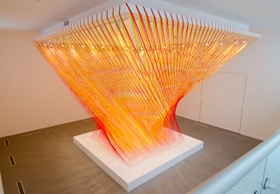
Rewritten by machine on new technology (2013)
Installed at the Lancaster Museum of Art and History (MOAH)
Lancaster, CA
Materials: flagging tape, eye hooks, pedestal and existing architecture
Dimensions: 30x32'x30', pedestal is 20x20'x16"

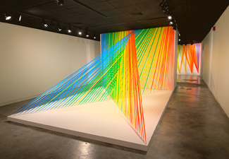
No chance to look backwards and see (2012-13)
Installed at Utah Museum of Contemporary Art (UMOCA)
Salt Lake City, UT
Materials: flagging tape, stainless steel, eye hooks, wood, paint, existing architecture and pedestals

For more of Geckler’s work go to megangeckler.com

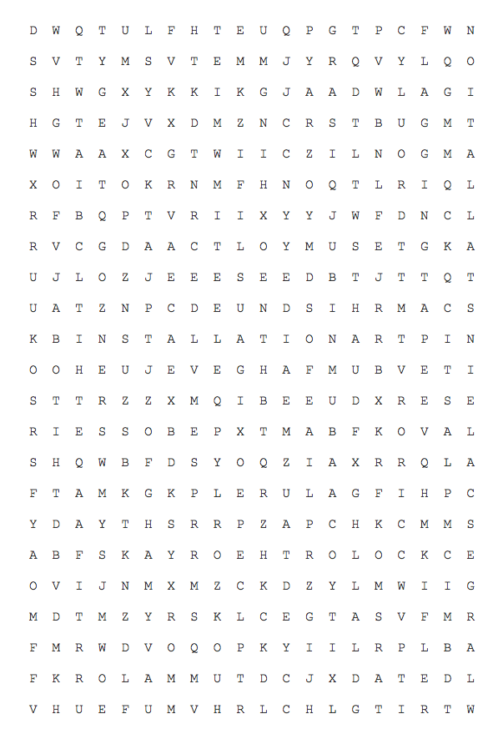
Step 5: Prep your space of choice with all the hardware and additional materials you might need for your artwork.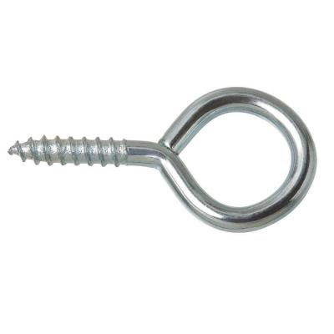 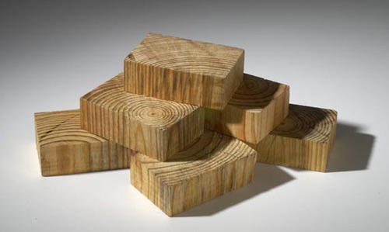

Step 6: Transform your space into something amazing.
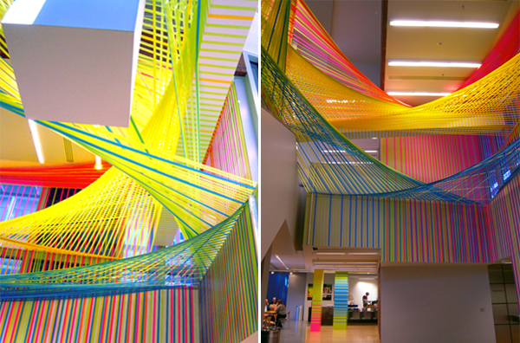

P.S. It might take us one day or more to complete our flagging tape installation.
Step 4: Draw a 3D picture of sketches of what you want your design/installation to look like.

Definitions for Vocabulary Puzzle
Please find the bold vocabulary words in the puzzle

- Flagging tape- Colored non-adhesive tape used in marking onjects.
- Color theory- Body of practical guidance to color mixing and visual effects of color combinations.
- Site-specific Art- Artwork created to exist in a certain place. Typically, the artist takes the location into account while planning and creating the artwork.
- Contemporary Art- Art produced at the present period in time.
- Architecture- Process and product of planning, designing, and constructing buildings and other physical structures.
- 3D modeling- Process of developing a mathematical representation of any surface of an object via specialized software.
- Installation Art- Artistic genre of 3D works that are often site-specific and designed to transform the perception of a space. It can be either temporary or permanent art.
- Large-scale installation- all of the work is of monumental scale, engaging audiences and onlookers in a memorable experience.
- Plastic- Material that is in a wide range of synthetic or semi-synthetic organic solids that are malleable.
Activity
Please follow the steps to create your own site-specific installation artwork.

Step 1: Find a site/location that will interest you to do your own installation.
Examples- park, school, classroom, home etc.

Step 2: Take countless pictures, measurements and plan unique spots for your installation.
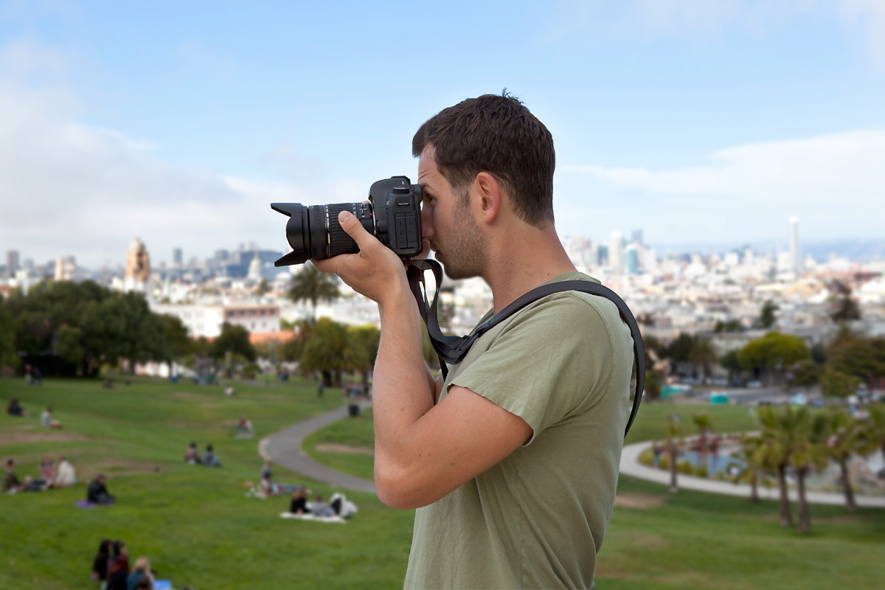

Step 3: Choose the colors of your flagging tapes that you are going to use for your piece of art.

